A Decade of Social Bot Detection
Bots increasingly tamper with political elections and economic discussions. Tracing trends in detection strategies and key suggestions on how to win the fight.
ON THE MORNING of November 9, 2016, the world wokeup to the shocking outcome of the U.S. Presidentialelection: Donald Trump was the 45th President ofthe United States of America. An unexpected eventthat still has tremendous consequences all overthe world. Today, we know that a minority of socialbots—automated social media accounts mimickinghumans—played a central role in spreading divisivemessages and disinformation, possibly contributingto Trump’s victory.16,19In the aftermath of the 2016 U.S. elections, the worldstarted to realize the gravity of widespread deception insocial media. Following Trump’s exploit, we witnessedto the emergence of a strident dissonance betweenthe multitude of efforts for detecting and removingbots, and the increasing effects these malicious actorsseem to have on our societies.27,29 This paradox opens aburning question: What strategies should we enforce inorder to stop this social bot pandemic?In these times—during the run-up to the2020 U.S. elections—the question ap-pears as more crucial than ever. Particu-larly so, also in light of the recent report-ed tampering of the electoral debate bythousands of AI-powered accounts.aWhat struck social, political, andeconomic analysts after 2016—decep-tion and automation—has been a mat-ter of study for computer scientistssince at least 2010. In this work, webriefly survey the first decade of re-search in social bot detection. Via alongitudinal analysis, we discuss themain trends of research in the fightagainst bots, the major results thatwere achieved, and the factors thatmake this never-ending battle so chal-lenging. Capitalizing on lessonslearned from our extensive analysis, wesuggest possible innovations thatcould give us the upper hand againstdeception and manipulation. Studyinga decade of endeavors in social bot de-tection can also inform strategies fordetecting and mitigating the effects ofother—more recent—forms of onlinedeception, such as strategic informa-tion operations and political trolls.The Social Bot PandemicSocial bots coexist with humans sincethe early days of online social net-works. Yet, we still lack a precise and well-agreed definition of what a socialbot is. This is partly due to the multi-ple communities studying them andto the multifaceted and dynamic be-havior of these entities, resulting indiverse definitions each focusing ondifferent characteristics. Computerscientists and engineers tend to de-fine bots from a technical perspective,focusing on features such as activitylevels, complete or partial automa-tion, use of algorithms and AI. The ex-istence of accounts that are simulta-neously driven by algorithms and byhuman intervention led to even morefine-grained definitions and cyborgswere introduced as either bot-assistedhumans or human-assisted bots. 3 In-stead, social scientists are typicallymore interested in the social or politi-cal implications of the use of bots anddefine them accordingly.
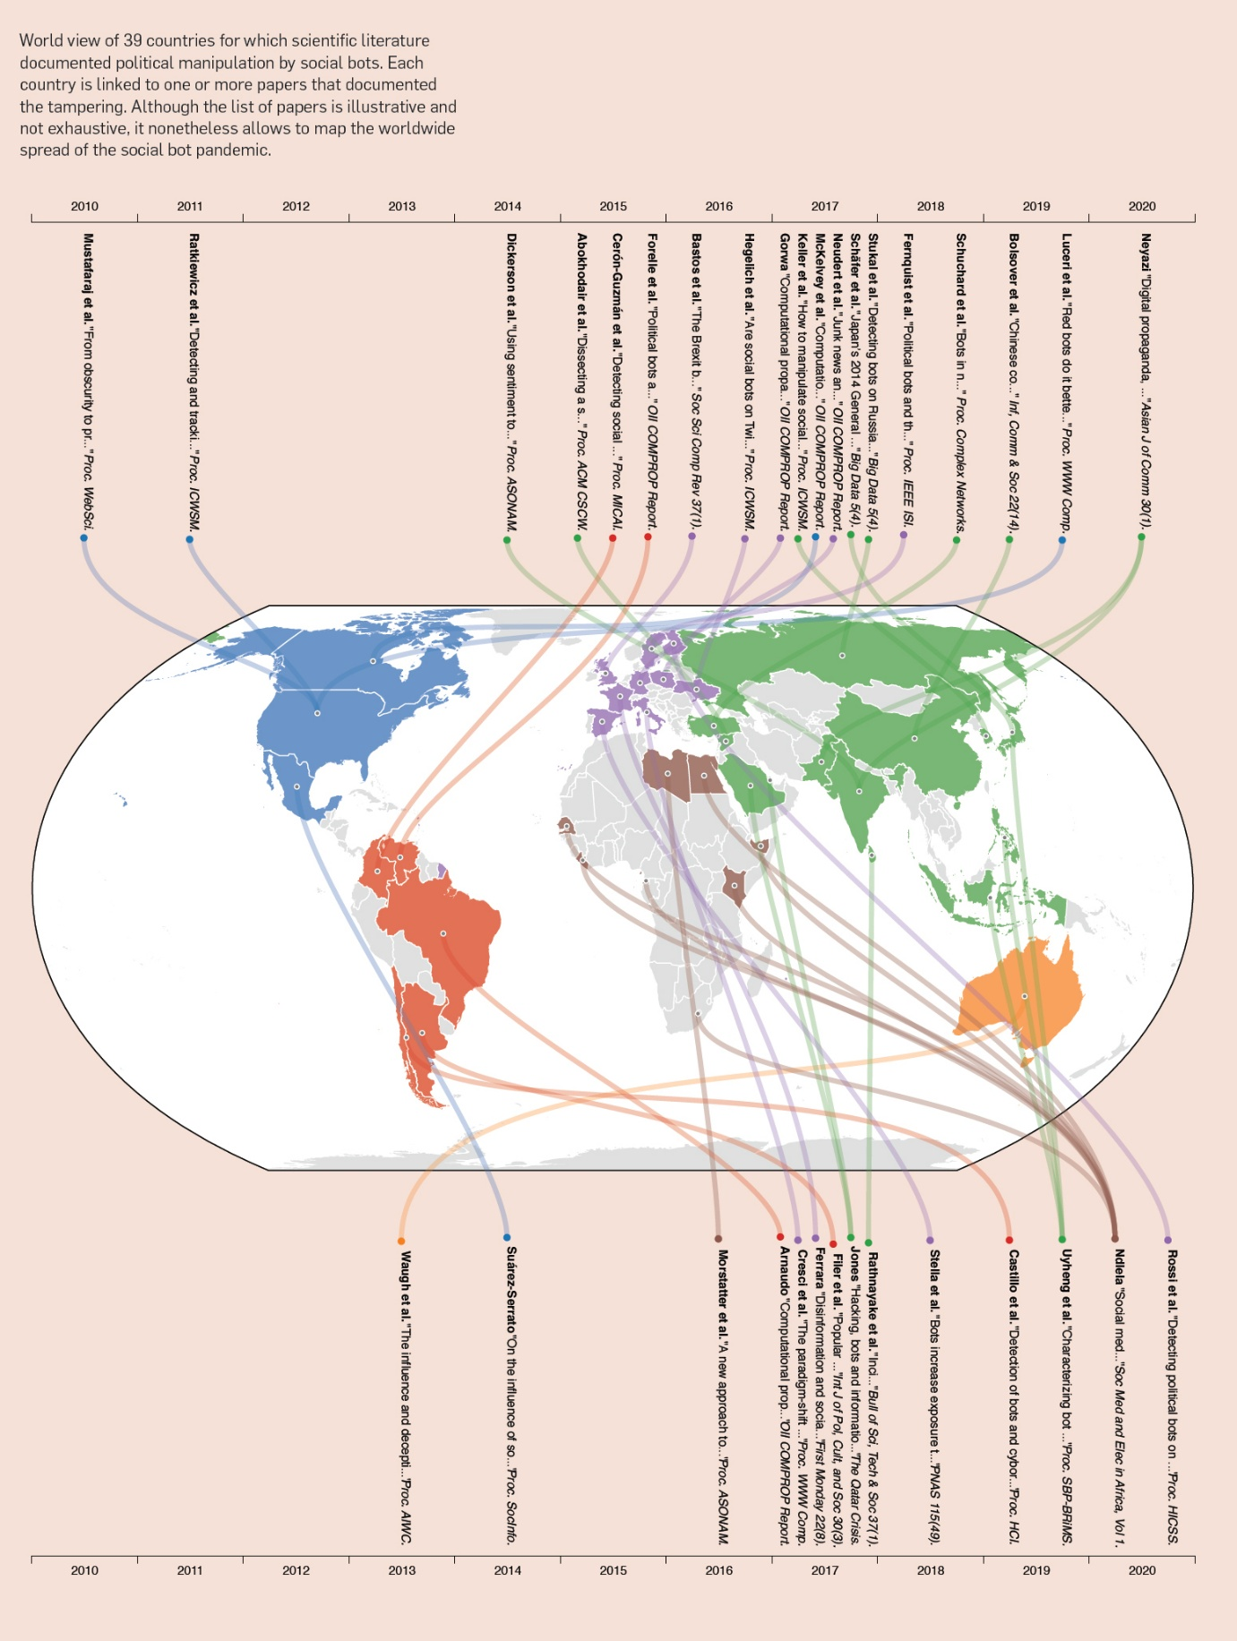
The Issue of Bot EvolutionInitial success at social bot detectionforced bot developers to put in placesophisticated countermeasures. Be-cause of this, newer bots often featureadvanced characteristics that make them much more difficult to detect.

Authors – Stefano Cresci, ACM
Year – 2020
Problem – Social Bot Detection
Dataset – Multiple studies and crowd-sourcing experiment, in the span of 2011-2016;
Accuracy - Yang’s classifier was no longer successful. Tech savvy users also only spotted newer bots 24% of the time, while the older ones were at 91% spotted chances.
Limitations – Older models were not successful.
The paper highlighted the shift in bot dynamics, bot detectors published per type (individual and grouped; adversarial, crowdsourcing, heuristics, super and unsupervised). Proposed that “Devising techniques for spotting suspiciously coordinated and synchronized behaviors is likely to yield better results than analyzing individual accounts”.

Machine learning-based social media bot detection: a comprehensive literature review

- Authors - Malak Aljabri,
- Rachid Zagrouba,
- Afrah Shaahid,
- Fatima Alnasser,
- Asalah Saleh &
- Dorieh M. Alomari

Year – January 2023
Abstract - In today’s digitalized era, Online Social Networking platforms are growing to be a vital aspect of each individual’s daily life. The availability of the vast amount of information and their open nature attracts the interest of cybercriminals to create malicious bots. Malicious bots in these platforms are automated or semi-automated entities used in nefarious ways while simulating human behavior. Moreover, such bots pose serious cyber threats and security concerns to society and public opinion. They are used to exploit vulnerabilities for illicit benefits such as spamming, fake profiles, spreading inappropriate/false content, click farming, hashtag hijacking, and much more. Cybercriminals and researchers are always engaged in an arms race as new and updated bots are created to thwart ever-evolving detection technologies. This literature review attempts to compile and compare the most recent advancements in Machine Learning-based techniques for the detection and classification of bots on five primary social media platforms namely Facebook, Instagram, LinkedIn, Twitter, and Weibo. We bring forth a concise overview of all the supervised, semi-supervised, and unsupervised methods, along with the details of the datasets provided by the researchers. Additionally, we provide a thorough breakdown of the extracted feature categories. Furthermore, this study also showcases a brief rundown of the challenges and opportunities encountered in this field, along with prospective research directions and promising angles to explore.

Problem – Malicious bots that are not benign and fabricate account, fake engagements etc. Social media security.
Methodology and Dataset – Various platforms (twitter, facebook, insta, linkedin, Weibo). Types of bots – spambots, social bots, sybil bots, and cyborgs.
Spambots – promoters, URL spambots
Social bots – algorithmically controlled user accounts
Cyborgs – half human half bot accounts
Sybils – anonymous user identities
ML techniques - However, we have only included Supervised, Semi-supervised, and Unsupervised as a part of our study. Three types are present under supervised category: Classification, Regression, and Forecasting. Some of the most popular supervised algorithms include Random Forest (RF), Naïve Bayes (NB), Decision Trees (DT), Logistic Regression (LR), Support Vector Machine (SVM), Neural Networks (NN), and many more. Deep learning (DL) is a subset of supervised ML techniques that employs multiple layers to gradually extract higher-order features from the input data. In order to create patterns and process data, this AI technology mimics the actions and processes of the human brain (Gannarapu et al. 2020). Convolutional Neural Networks (CNNs), Long Short-Term Memory Networks (LSTMs), Generative Adversarial Networks (GANs), etc., are some of the well-known DL algorithms. Whereas unsupervised learning algorithms are namely categorized into Clustering and Association which mainly deal with unlabeled data. Some of the primarily used ones include K-nearest Neighbor (KNN), K-means clustering, Principal Component Analysis (PCA), etc. However, a small amount of labeled data and a large amount of unlabeled data are utilized in semi-supervised learning, which results in a hybrid of supervised and unsupervised learning (Mahesh 2020).

1.6 Key contributions
This section firstly puts forth the existing literature reviews done on different social media platforms as shown in Table 1. It also briefly discusses the previously used taxonomies along with the prevailing gaps. Starting with the literature review on Twitter, (Alothali et al. 2019) included literature concerning from 2010 to 2018 based on various techniques which include Graph-based, Crowdsourcing, and ML. They analyzed the common aspects such as datasets, classifiers, and the selected features employed. The challenges present in the domain were also addressed. (Derhab et al. 2021) discussed existing techniques and put forth a taxonomy that addressed the state-of-the-art tweet-based bot detection techniques in the timeline from 2010 to 2020. Based on tweet-based bot detection techniques, they provided the main features utilized. For tweet-based bot detection, they also described big data analytics shallow and DL techniques, in addition to their performance results. Finally, the challenges and open issues in the area of tweet-based bot detection were presented and discussed (Derhab et al. 2021). Furthermore, (Orabi et al. 2020) discussed the studies from 2010 to 2019 on Graph-based, ML-based, Crowdsourcing, and Anomaly-based. Their research revealed some gaps in the literature, such as the fact that studies discussed mainly Twitter, and that unsupervised ML is rarely used, in addition to the majority of publicly available datasets being either inaccurate or insufficiently large. In (Gheewala and Patel 2018), contributed a review on ML twitter spam detection for the years 2010–2017 based on Clustering, Classification, and Hybrid algorithms. Some of the issues concluded were regarding the results being lowered as a result of concerns with feature fabrication, class imbalance, spam drift, etc., for spam detection. The study (Ezarfelix et al. 2022) performed was based only on the Instagram platform where a multitude of analyses, and evaluations have been performed on the studies from 2018 to 2021. It was concluded that in order to detect fake accounts, using NN is the most effective method. (Rao et al. 2021) presented a comprehensive review of the social spam detection techniques studied from 2015 to 2020 based on different social spam detection techniques which include Honeypot/Honeynet-based techniques, URL List-based spam filtering techniques, and ML and DL techniques. Numerous feature analysis and dimensionality reduction techniques used by different researchers were outlined. A thorough analysis was given, describing the datasets utilized, features used, ML/DL models used, performance measures used, and pros and cons of each model.

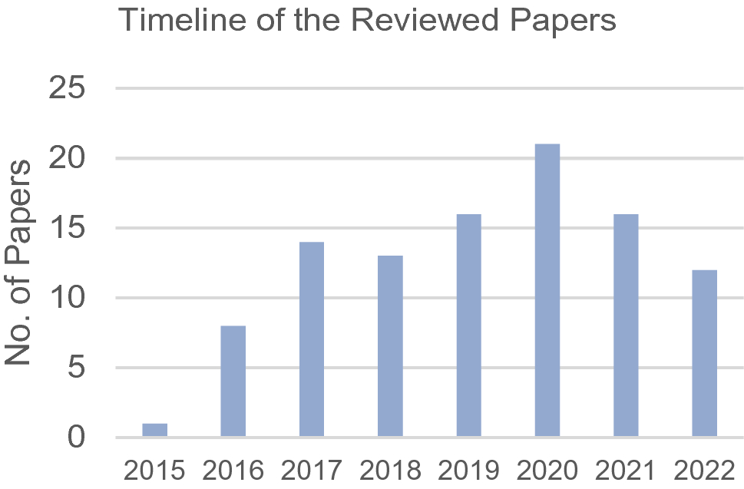

The paper discusses how to detect different types of bots across the platforms mentioned above, best approaches and such.

Social media bot detection with deep learning methods: a systematic review
- Authors- Kadhim Hayawi,
- Susmita Saha,
- Mohammad Mehedy Masud,
- Sujith Samuel Mathew &
- Mohammed Kaosar

Year – March 2023
Problem – Detection of sophisticated bots in the market by using specifically DL techniques
Dataset – “To the best of our knowledge, six review articles have been published so far in this field highlighting social bot detection techniques and taxonomy (see details in supplementary Table S1). Hence, the existing surveys cover the broader field of social bot detection, highlighting all of the technical approaches such as structure-based, crowdsourced, hybrid, graph-based, machine learning and other techniques such as dynamic time warping, digital DNA-based or natural language processing (NLP) approaches [8, 13,14,15,16,17]. We have found at least one review article that surveyed machine learning algorithms in general for different categories of social media analysis including bot detection”

Gaps and contribution-
The motivation behind the current systematic review on only the deep learning articles for social media bot detection is mainly based on two reasons. First, the DL approaches showed high potential to detect the benign/malicious bots and to keep pace with their fast-evolving and highly variable characteristics, which is a pressing need right now. Second, none of the previous systematic reviews attempted to synthesize the efficacy, failure and challenges of exclusively these techniques for social media bot detection. It is important to figure out the status of the deep learning research in comparison with other techniques, including the classical machine learning algorithms, to guide the future research in social media bot detection to the right direction and to maximize the usability of current data sources. Third, while a previous review article presented machine learning research in general for social media, narrowing it down to social media bot detection and going deeper from both technical and application points of view is crucial for ensuring future success in this field.

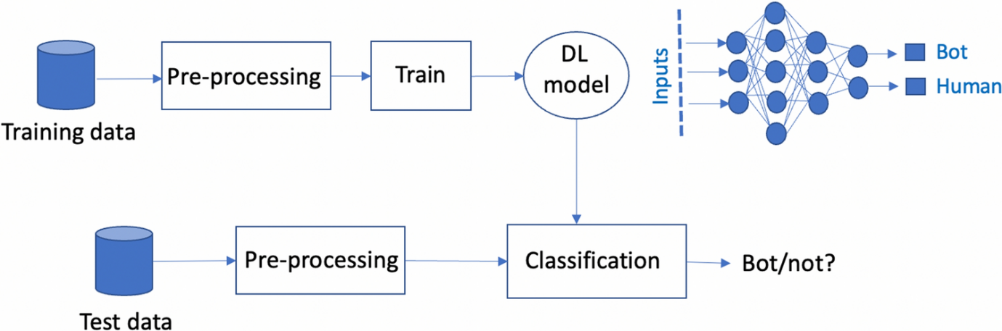

The main contribution of our work can be summarized as follows:
- We provide a systematic review of various DL approaches which have been used particularly in social media bot detection, including all the related literature found between 2000 and 2021, from pre-defined resources, and based on pre-defined inclusion/exclusion criteria. Out of 1496 obtained publications using the search term, 40 are finally selected for this review. Up to the best of our knowledge, it is the first systematic review conducted on this topic.
- We present a comparative study among DL algorithms and between DL and traditional ML approaches for the bot detection task. It is worth mentioning here that only the comparisons with ML, as reported in the DL articles, were presented and analysed in this review.
- We provide the summary of the datasets, taxonomy of the features and their extraction mechanism that are extensively used for DL approaches in this field.
- We provide the future research direction by informing the researchers of the high potential of these approaches as well as of the current gaps and challenges.

Methodology-
3.1 Research questions
For this review, the authors followed the guidelines suggested by [22] for conducting a systematic literature review (SLR).
- RQ1 What are the deep learning algorithms that are used for social bot detection or prediction?
- RQ2 What are the pre-processing mechanisms needed for the above algorithms?
- RQ3 What is the effectiveness (success or failure) of different DL models in association with combinatory feature inputs (multimodal inputs, e.g. user data, posts, etc.) for social bot detection?
- RQ4 How is the performance of deep learning algorithms in comparison with traditional machine learning models?
- RQ5 What are the gaps and future research directions in this area?

3.2 Search strategy

The search is conducted in several stages: primary term-based search in three of the largest databases including Google Scholar/Scopus/ScienceDirect, crawling in published literature/systematic reviews for any missing papers (journal articles and conference proceedings), manual screening over the title and abstracts and finally applying exclusion and inclusion criteria to generate the targeted set of publications for review. We also informally searched over other databases such as IEEE/ACM to find any missing ones and did not find anything additional. The abstract screening and the outcome of search using scoping criteria were assessed based on the agreement among the researchers on each paper.

We used Rayyan Intelligent Systematic Review software^{Footnote3} for an organized screening of the papers with the above-mentioned steps.

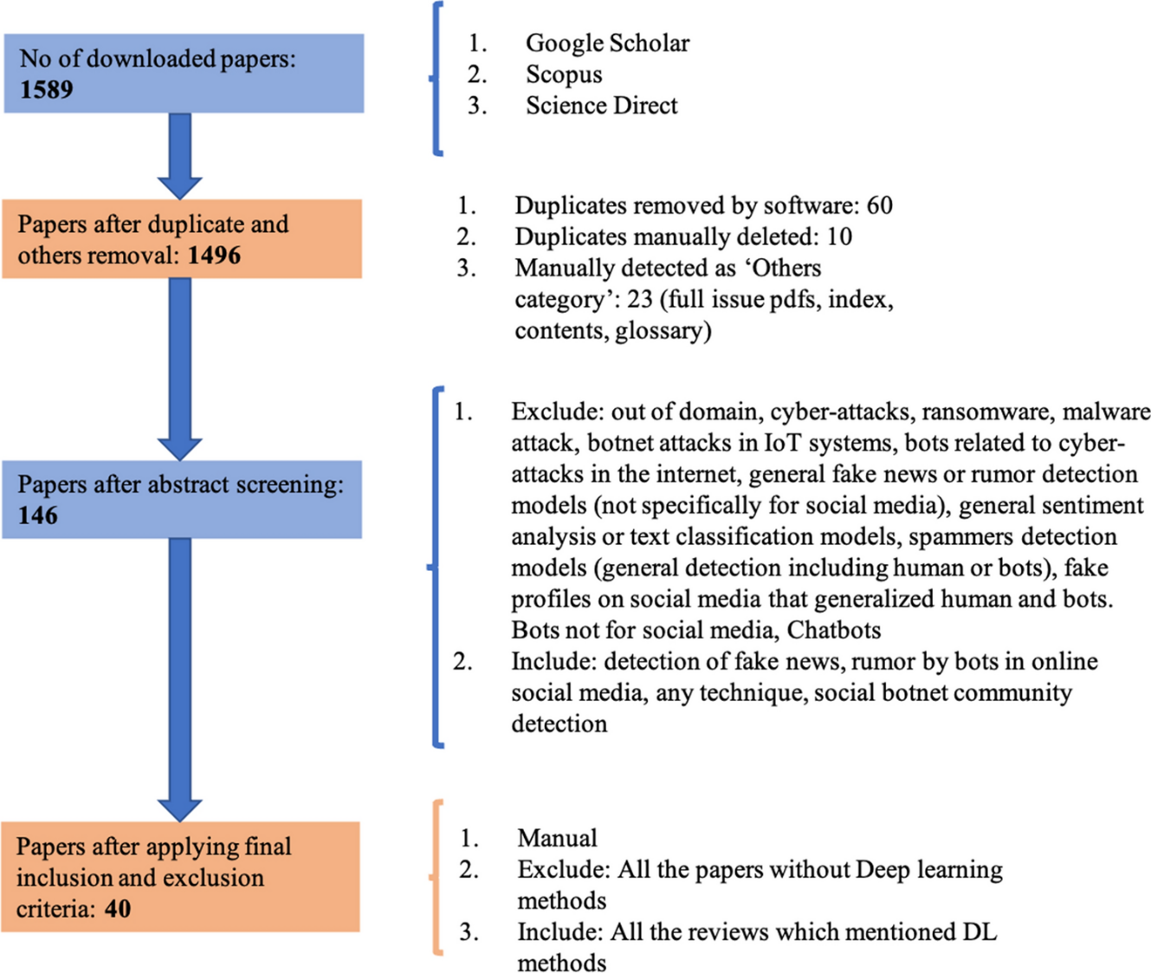
Result and accuracy –
https://link.springer.com/article/10.1007/s00521-023-08352-z/tables/1
The holistic analysis will validate the information that the cutting-edge artificial intelligence techniques are generally working well in this field, and in addition to traditional ML algorithms, the future researchers might want to consider deep learning models for their study. This will help the researchers to find out the best suitable approach in terms of the model architecture, feature extraction, pre-processing mechanism and sample size for their particular dataset and objective of the study. If any model performance is worse or the approach has limitations, we have identified the reason and, in contrast, emphasized on their unique benefits. The key approach here is the same, i.e. the use of deep learning to deal with the highly heterogenous and evolving social media bots.

A number of social media bot detection studies used different combinations of deep convolutional neural network (CNN), LSTM, recurrent neural network (RNN) and gated recurrent units (GRU). Ping and Qin [35] achieved the highest performance with 100% accuracy among all. The main characteristic of their proposed model was the use of tweet content and temporal features in a fused way. In general, CNNs work better to classify textual content and identify abuses, angry terms, named entities, etc.; however, representing the textual data in a vectorized form through language models such as Word2Vec was essential. In contrast, LSTMs and RNNS are both highly useful for finding the relationship between the consecutive time point data, where sequence of sentence is important.
In comparison, the behaviour enhanced deep model (BeDM) was only giving 88.41% precision even with a large sample size of 2 million in each bot and human classes.
Sengar, Kumar [23] used an interesting model architecture with a machine learning classifier for the final prediction labels achieving an accuracy of around 90% and precision of 92%.
Multilayer perceptron/feed-forward neural network: max accuracy: 99.92%

Tweet-Based Bot Detection Using Big Data Analytics
Author - Abdelouahid Derhab; Rahaf Alawwad; Khawlah Dehwah; Noshina Tariq; Farrukh Aslam Khan; Jalal Al-Muhtadi

Year – 2021
IEEE
Problem – Twitter due to popularity has especially been targeted by different attacks - spreading rumors, phishing links, and malware.
Dataset –

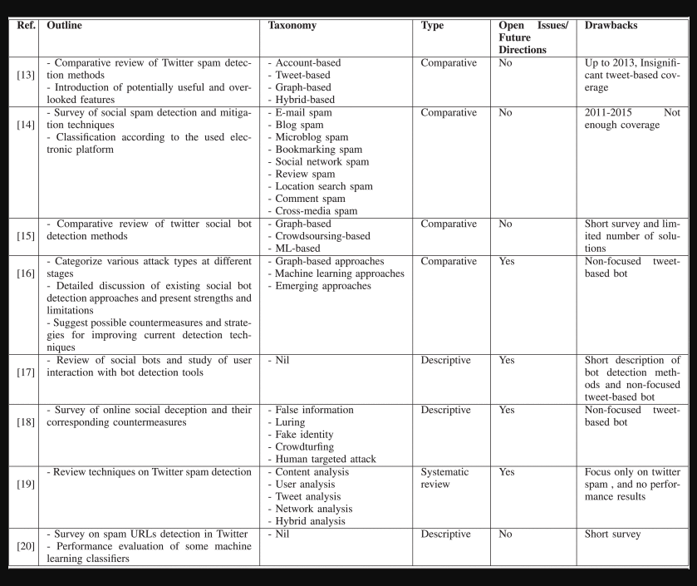

Method –
This review aims at providing an overview of different tweet-based bot detection methods that use shallow and deep learning techniques to distinguish between human accounts and bot accounts. In particular, the main contributions of the paper are the following:
- A taxonomy, which classifies the state-of-the-art on machine learning techniques for tweet-based bot detection, is presented.
- A comprehensive review is presented on shallow and deep learning techniques for tweet-based bot detection, which covers the solutions up to year 2020.
- The challenges and open issues related to tweet-based bot detection are highlighted and discussed.

Accuracy –
LSTM – 96%
RNN + LSTM – 93% a 95% p
Variational autoencoder – 93% p 87% a
DQL – 93%
CNN – 85% and 97%p
LSTM and CNN outperform others in accuracy and precision respectively

Limitations –
Feature selection: Generally, the quality of the classifiers relies on the quality of selected features.
Dataset labeling: One of the challenges of tweet-based bot detection lies in the data labeling techniques. These techniques differ, hence their results also differ.
Dataset balancing: Human accounts are the majority of bot datsets as in [40], [90], or they represent an acceptable ratio as in [39]. To capture the true performance of the detection, precision and recall were utilized in place of accuracy. However, some literature [24] decided to handle it before detecting and producing synthetic data.
False positives: Generally, most mentioned literature has a good performance. However, there is still an issue with misclassifying human accounts (i.e., incurring false positives), which do not improve the recall performance for bot detection.
Detection evasion: Some bot accounts have little or no information related to botnet campaigns, and hence they can evade detection [91], especially if they are inactive.
Language diversity support: The majority of detection tools and algorithms are designed to deal with the English language, and there are few research works that consider other languages.
Botnet infrastructure detection: The issue about using online platforms, such as social networks, as botnet infrastructures for Command and Control (C&C) is also important [94].

Conclusion-
Twitter is one of the most popular social media platforms that allows connecting people and helps organizations reaching out to customers. Tweet-based botnet can compromise Twitter and create malicious accounts to launch large-scale attacks and manipulation campaigns. In this review, we have focused on big data analytics, especially shallow and deep learning to fight against tweet-based botnets, and to accurately distinguish between human accounts and tweet-based bot accounts. We have discussed related surveys, and have also provided a taxonomy that classifies the state-of-the-art tweet-based bot detection techniques up to 2020. In addition, the shallow and deep learning techniques are described for tweet-based bot detection, along with their performance results. Finally, we presented and discussed the open issues and future research challenges.

Deep Neural Networks for Bot Detection
Authors - Sneha Kudugunta ª, Emilio Ferrara ^{b}
Elsevier
Year – 2018
Problem - The problem of detecting bots, automated social media accounts governed by software but disguising as human users, has strong implications. For example, bots have been used to sway political elections by distorting online discourse, to manipulate the stock market, or to push anti-vaccine conspiracy theories that may have caused health epidemics.

Methodology - Most techniques proposed to date detect bots at the account level, by processing large amounts of social media posts, and leveraging information from network structure, temporal dynamics, sentiment analysis, etc. In this paper, we propose a deep neural network based on contextual long short-term memory (LSTM) architecture that exploits both content and metadata to detect bots at the tweet level: contextual features are extracted from user metadata and fed as auxiliary input to LSTM deep nets processing the tweet text.

Dataset - Another contribution that we make is proposing a technique based on synthetic minority oversampling to generate a large labeled dataset, suitable for deep nets training, from a minimal amount of labeled data (roughly 3000 examples of sophisticated Twitter bots).
The dataset used in our work is the one presented by Cresci and collaborators [12], which contains an entirely new breed of social bots. We use a mixture of the groups genuine accounts, social spambots #1, social spambots #2 and social spambots #3.
All these subsets of data combined together account for 8386 user accounts, and 11,834,866 tweets to train on. A group-wise breakdown may be seen in Table 1.

Accuracy - We demonstrate that, from just one single tweet, our architecture can achieve high classification accuracy (AUC > 96%) in separating bots from humans. We apply the same architecture to account-level bot detection, achieving nearly perfect classification accuracy (AUC > 99%).

Contributions - The contributions we provide here aim to address these challenges:
- 1.
We advance the problem of classifying individual social media accounts from single observations, i.e., determining whether a single tweet comes from a Twitter bot or from a human user. We demonstrate that tweet-level bot detection is possible and can be very accurate: by exploiting both textual features and tweet metadata, we detect bots from single tweets and even exceed the performance of earlier works that make use of a given user’s entire profile and recent posting history.
- 2.
As a technical contribution, we introduce the concept of a Contextual LSTM (Long Short-Term Memory) deep neural network [23], an architecture that takes both the tweet text and the tweet metadata as an input. Related architectures that use side-information to enhance recurrent model representations have been alluded to by some authors before, primarily in the context of language models, but has never been used in the context of social media classification—to the best of our knowledge. The proposed architecture allows us to reach state-of-the-art performance in bot detection (i.e., over 96% AUC scores).
- 3.
Finally, we introduce a technique based on the usage of synthetic minority oversampling [9] to enhance existing datasets by generating additional labeled examples. This will allow us to achieve near perfect classification performance on the account-level bot detection task, by leveraging only a minimal number of features and very small training datasets.

Limitations
Much work on bot detection assumes extensive access to social media data. For example, Wang and collaborators used clustering techniques to identify large-scale behavioral anomalies [48], while other authors adopted supervised learning to analyze all accounts of some platform and separate bots from humans [38], [50]. Although these approaches can be useful, for example to detect large-scale bot infiltrations, they can be implemented exclusively by social media service providers with full access to data and systems.
To allow for bot detection at the user level, all these methods still require the analysis of some historical user data, either by indirect data collection [10], [11], [48], or, like in the case of BotOrNot [13], by interrogating the Twitter API (which imposes strict rate limits, making it impossible to do large-scale bot detection).

Conclusions
Given the prevalence of sophisticated bots on social media platforms such as Twitter, the need for improved, inexpensive bot detection methods is apparent. We proposed a novel Contextual LSTM architecture allowing us to use both tweet content and metadata to detect bots at the tweet level. From a single tweet, our model can achieve an extremely high accuracy exceeding 96% AUC.

TwiBot-20: A Comprehensive Twitter Bot Detection Benchmark

Authors:
Shangbin Feng, Herun Wan, Ningnan Wang, Jundong Li, Minnan Luo

Date – October 2021

ACM

Problem - Successful Twitter bot detection proposals are generally supervised, which rely heavily on large-scale datasets. However, existing benchmarks generally suffer from low levels of user diversity, limited user information and data scarcity. Therefore, these datasets are not sufficient to train and stably benchmark bot detection measures.

Methodology - To alleviate these problems, we present TwiBot-20, a massive Twitter bot detection benchmark, which contains 229,573 users, 33,488,192 tweets, 8,723,736 user property items and 455,958 follow relationships.

Datasets used-
Dataset | Year | Description
caverlee-2011 | 2011 | One of the earliest Twitter bot detection datasets. Collected from Dec 30, 2009 – Aug 2, 2010. Contains 22,223 content polluters and 19,276 legitimate users.
cresci-2015 | 2015 | Dataset containing genuine Twitter accounts and fake follower accounts.
varol-2017 | 2017 | Contains 2,573 manually annotated Twitter accounts for bot detection.
vendor-purchased-2019 | 2019 | Consists of fake follower accounts purchased online from vendors.
midterm-18 | 2018 | The largest Twitter bot detection dataset mentioned, with 50,538 annotated users.
verified-2019 | 2019 | A Twitter bot detection dataset containing verified accounts (introduced in the same benchmark paper as midterm-18).
botwiki-2019 | 2019 | Dataset of Twitter bot accounts collected from Botwiki.
cresci-rtbust-2019 | 2019 | Dataset associated with the RTbust bot detection work by Cresci et al.
Astroturf | 2014 (commonly referenced) | Dataset related to astroturfing/campaign manipulation on Twitter, used for bot detection research.

Contributions –
TwiBot-20 covers diversified bots and genuine users to better represent the real-world Twittersphere.
TwiBot-20 also includes three modals of user information to support both binary classification of single users and community-aware approaches.
Largest bot detection benchmark to date (2021)
Performance
- All bot detection baselines achieve significantly lower performance on TwiBot-20 than on cresci-17 or PAN-193. This indi-cates that our TwiBot-20 is more challenging and social mediabot detection is still an open problem.•
- Alhosseini et al. [ 1] applies graph convolutional network to the task of Twitter bot detection, which demands that bot detection datasets include user neighborhood information. As Cresci etal. [ 8 ] points out, studying user communities is essential in future bot detection endeavors, where TwiBot-20 enables it by providing users’ neighborhood information and the two other datasets fall short.
- From the comparison between Wei et al. [29] and Kudugunta etal. [ 14 ], where both baselines use semantic information but the latter method also leverages user properties, it is demonstrated that the performance gap between two baselines is significantly larger on our proposed TwiBot-20 than on cresci-17. This indicates that apart from being a toy example, TwiBot-20 is relatively more complex, where bot detectors need to leverage more user information in order to perform well.
- Botometer [ 9 ] is a publicly available bot detection demo. Although it succeeds in capturing bots in cresci-17 where users in the dataset were collected back in 2017, it fails to match its previous performance on TwiBot-20, where users are collected in 2020. This demonstrates that the real-world Twittersphere has shifted and Twitter bots have evolved to evade previous detection methods, which calls for new research efforts and more up-to-date benchmarks like TwiBot-20.•
- For feature engineering based methods such as Lee et al. [16 ] and Yang et al. [ 32], their performance drops significantly from cresci-17 to TwiBot-20. This trend indicates that failing to incorporate semantic and neighborhood information leads to worse performance on more recent datasets. This could again be attributed to the evolution of Twitter bots, thus future bot detection methods should leverage increasingly diversified and multi-modal user information to achieve desirable performance.

